691223401884
87013509555

ЖАМАНГАРАЕВА Гульнара Абдуллаевна,
"Төрткүл' жалпы білім беретін мектебінің ағылшын тілі пәні мұғалімі.
Түркістан облысы, Ордабасы ауданы

MY FAVORITE HOBBY.MY GENERATION

Learning objectives | 9.4.1.1 understand the main points in extended texts on a range of unfamiliar general and curricular topics;  9.5.3.1 write with moderate grammatical accuracy on a wide range of familiar general and curricular topics.
Lesson objectives  (A.C) | Learners will be able to:  - Comprehend the core idea of the text with support (if needed);  - Write about the hobby he/she would like to take up with reasons using accurate grammar.

Stages/Time | Teachers actions | Students’ actions | Assessment | Resources
Beginning of the lesson  1 min.  2 min.  3 min.  5 min.  3 min.  8 min. | Organization moment (focus on speaking)  T. Greets the students and asks how they are, what news they have to share and talks a bit about the weather. T. asks the students to look on the white board and tell the class what is shown in the photos. There are the photos of different hobbies T. asks the learners:  What is the theme of the lesson?  Warm-up (pair work PW)  There are several questions on the screen relating to the hobbies and free time activities. The task is to ask and answer the questions in pairs.  What do you do in your free time?  What is your hobby?  What hobbies do you know?  What hobbies were popular 20 years ago?  Differentiation by pairing  (T. gives the students blue and green coloured stickers and in this way they are paired/ those who get the same colour work together)  Vocabulary presentation / (writing focus) adjectives  Activity 1  (individual work IW)  T. asks the students to look on the board and explains the usage of each adjective by using of missing letters .  The adjectives are:  - H_z_rd_us  - Co_v_n_ent  - R_lax_ng  - C_stl_  - Pr_ctic_l  - Am_si_g  - Ent_rtain__g  - S__ry  T. asks the students to make up sentences using adjectives and the types of hobbies and write them in their copybooks.  Teacher’s examples:  - I find cooking really relaxing  - Reading is entertaining especially when it has an interesting plot.  - Travelling is quite costly, mostly rich can afford themselves going abroad a lot.  Vocabulary expansion and speaking / types of hobbies  Activity 2  (Group work GW)  T. divides the students into three groups and gives them a sheet of paper and asks them to write the as many types of hobbies as possible in three minutes (the team that has written more in comparison with others will win.)  The list may consist of:  Reading  Cooking  Fishing  Collecting coins/ stamps/ specific toys  Gardening  Walking  Playing video games  Cycling  Singing  Painting  Dancing  Listening to music  Taking photos  Running a social media blog  And others  Differentiation by grouping  (less able students can give ideas in Kazakh language whereas more able students can translate them into English and other forms of support)  Writing  Activity 3 (pair work PW)  The students choose one of the hobbies and write the descriptions and swaps the work with others so the other pair should guess the type of hobby that has been described.  Differentiation by teacher’s support (the teacher helps the students when they need them) | Students greet the teacher and look at the board and guess the topic of the lesson  Students discuss the questions in pairs and randomly chosen students answers the questions orally to the whole class.  Descriptor:  A learner  -discuss the questions in pairs  -answer the questions to the whole class  Students make up their own sentences and write them in their copybooks and read them later.  Descriptor:  A learner:  -makes up true sentence  -uses adjectives  -read  Students write as many hobbies as possible  Descriptor:  A learner  -writes grammatical correct sentences  Students describe the type of hobby in written form  Descriptor::  A learner  - describes the hobby  -guess each other’s hobby type | At the organization moment T. tries to award active Ss. using «The praise» method to evaluate saying the phrases like:  “Good job!”  Well done!”  “Lovely!”  Formative Assessment  Teacher uses the praise method again saying:  Well done!  Brilliant!  Perfect job!  Can you try again! This time you did well!  Teacher assesses the students work approaching individually and marking their answers ‘good, well. Excellent.’  Self - assessment (they count their own hobbies and compares with others)  Assessment by the teacher (teacher gives the pairs some smileys who prepared a good description of the hobby and for those who find them correctly)  Assessment criterion:  Describe the hobby  Descriptors:  1.Correct spelling  2.Good description  3.Creative approach | White board  Photos with hobbies  White board  Stickers  PPT  Copybooks  Worksheets  Posters  Copybooks
Middle of the lesson  5 min.  5 min.  5 min.  6 min. | Reading / jigsaw reading (group and individual work GW/IW)  Text: My generation  T. divides the class into two and gives each group the part of the text and asks them to read and discuss in the group so all the members of the group understand the meaning of the text.  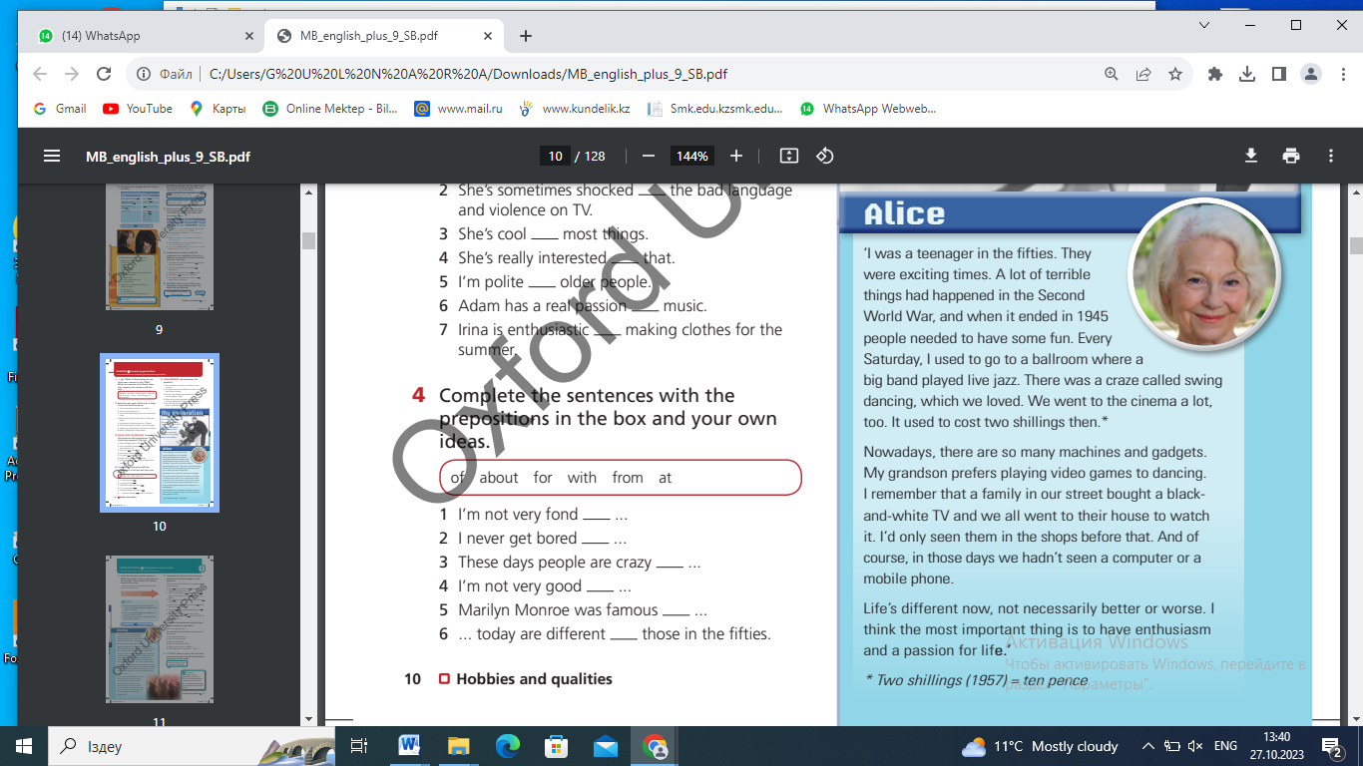  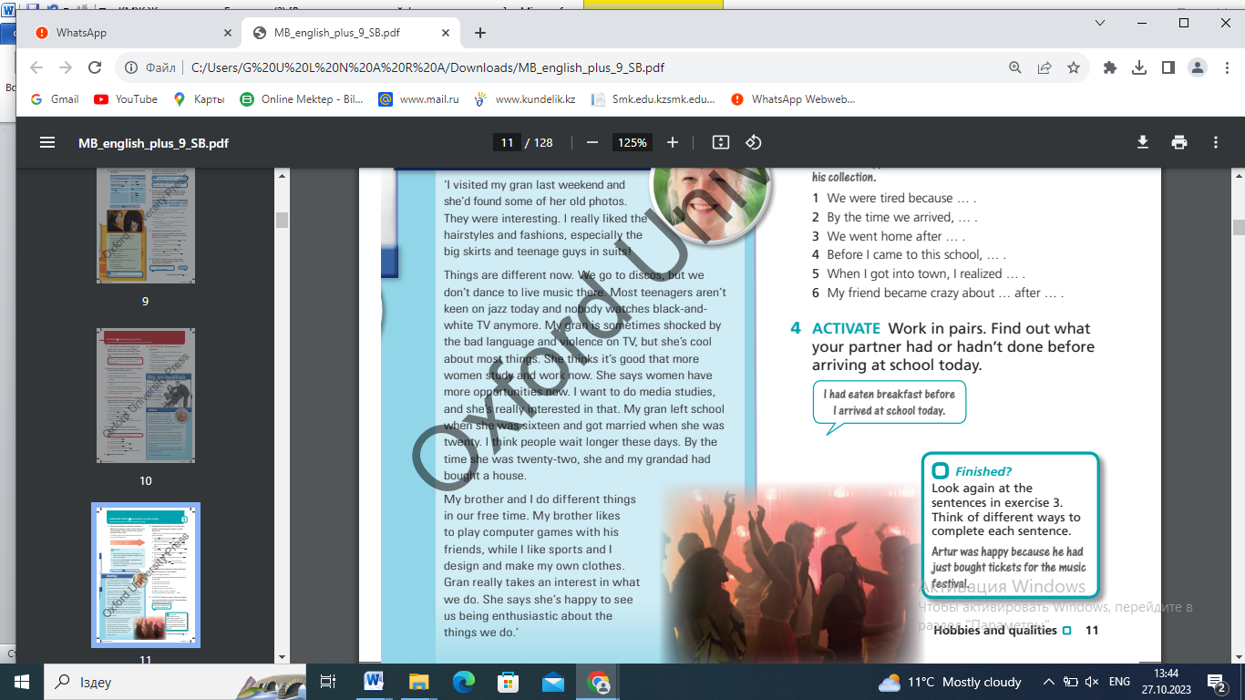  D :Less able leaners will be supported by learning environment  Task 2. While-reading task. True or False task. (Wh, I) (this task is for understanding according to reading skills)  Teacher asks students to read a text while reading identify if the sentences are T(true) or F(false) They circle right answer T(true) or F(false)  1.Going to the cinema was popular in 60s. T ….. F  2.Alice went to live jaz concert every Saturday. T ….. F  3.They had computers and mobile phones.T ….. F  4.Becky was interested in media studies. T ….. F  5.Most teenagers aren`t keen on jazz today.T….. F  D:Less able students would be supported by a teacher and more able students scaffolding  Post-reading/ retelling  Activity 5 (GW)  T. asks the learners to make up a new group so they can retell to one another their own parts. (there are two parts of the text: part 1 Alice and part 2 Becky).  After retelling the teacher randomly asks the students questions about the text and checks if they have understood the whole text or not.  The questions of the teacher:  What happened in the Second World war?  What did people need at that time?  Where did she use to go?  What did Alice say about cinema?  What did Alice say about today’s children’s preference?  What did she remember about black and white TV?  Did Becky like the hairstyle of her grandma’s when she was young?  What do teenagers do now?  What does Becky say about women now?  And others  Differentiation by task  (more able students give full, complex answers while less able ones give simple and short answers)  Writing  Activity 6(IW)  To recap all the material that has been taken the students are asked to write 3 sentences about the types of hobbies describing them using adjectives and also if they want they can use some true facts from the text.  Homework  To write a short essay about their favorite hobbies | Students read the text  Ss take word sheets and start the reading. while reading they identify True or False by circle T or F. Supports less able students in this activity if they ask for a help.  Descriptor:  a learner  -identifies true or false sentences  -recognizes the main point of reading text  Students retell their own parts to others and answer the questions of the teacher  Descriptor:  A learner:  -retells the part they have  -answers the teacher’s questions  Students write three sentences using learnt vocabulary and some facts from the text  Descriptor:  A learner  -writes grammatical correct sentences  -uses vocabulary | Assessment by the teacher using the praise words  Peer assessment (students swap their copybooks and check one another’s work) | Book  English Plus, grade 9, p.10  The text is attached below  Book  English Plus, grade 9, p.10  The text is attached below  Copybooks
End of the lesson  1 min. | Students share the opinion they have about the lesson | Tell the teacher if everything is ok or needs some improvements | Students reflect honestly answering the questions | Cards with questions about the attitude of the lesson
Homework  1 min. | Home task:  Writing an essay: My favorite hobby.

